**Daily Assignment-9**

**Date-**12/12/2024

Name: **Harish E.R**

1. Setting Up the Azure Repos:

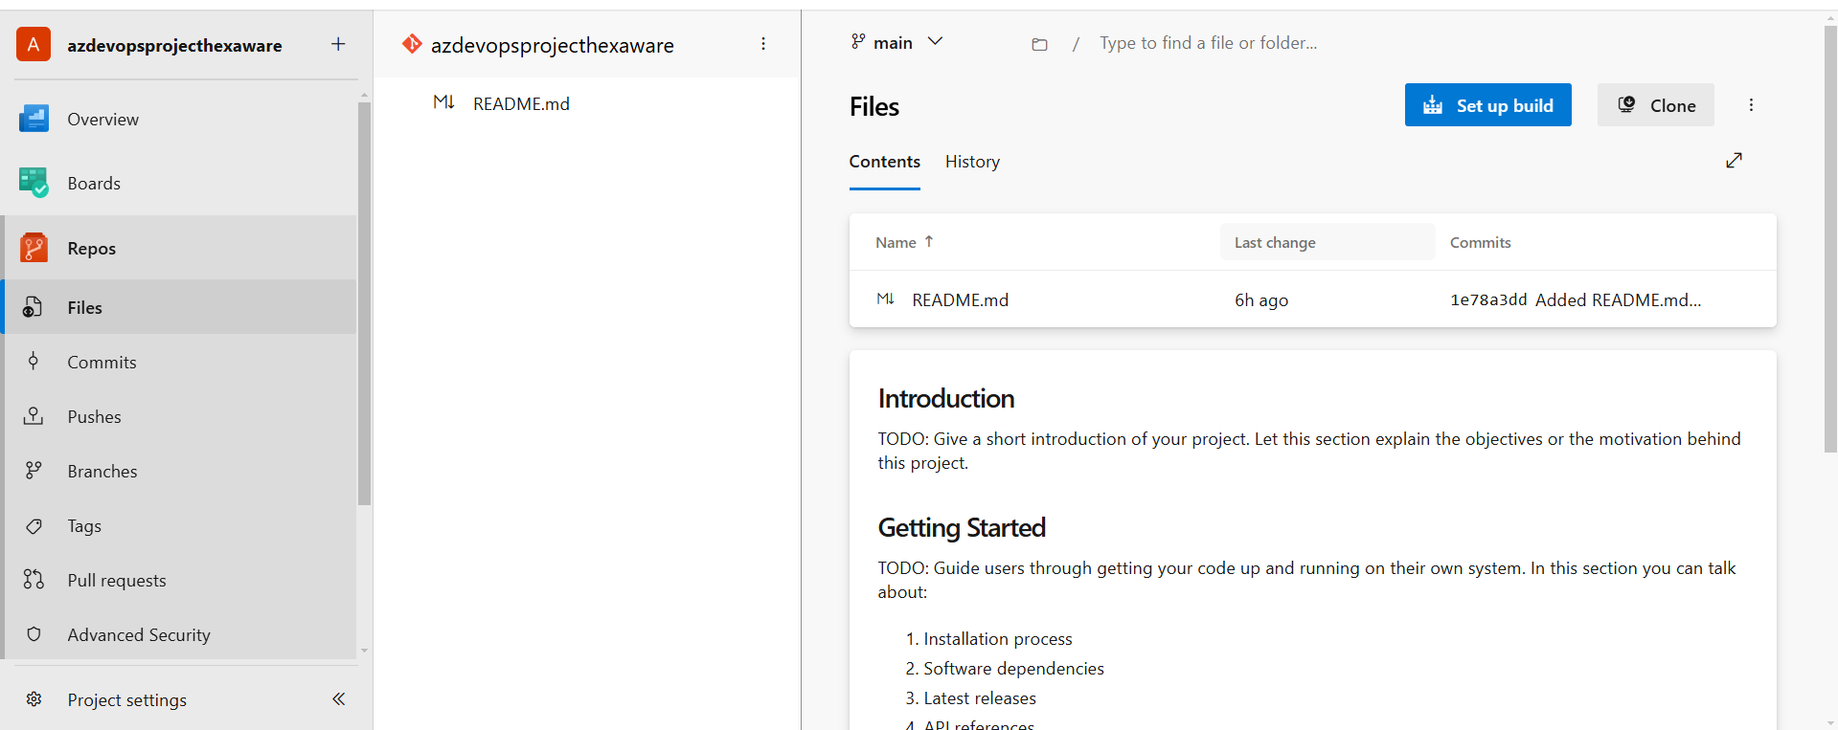

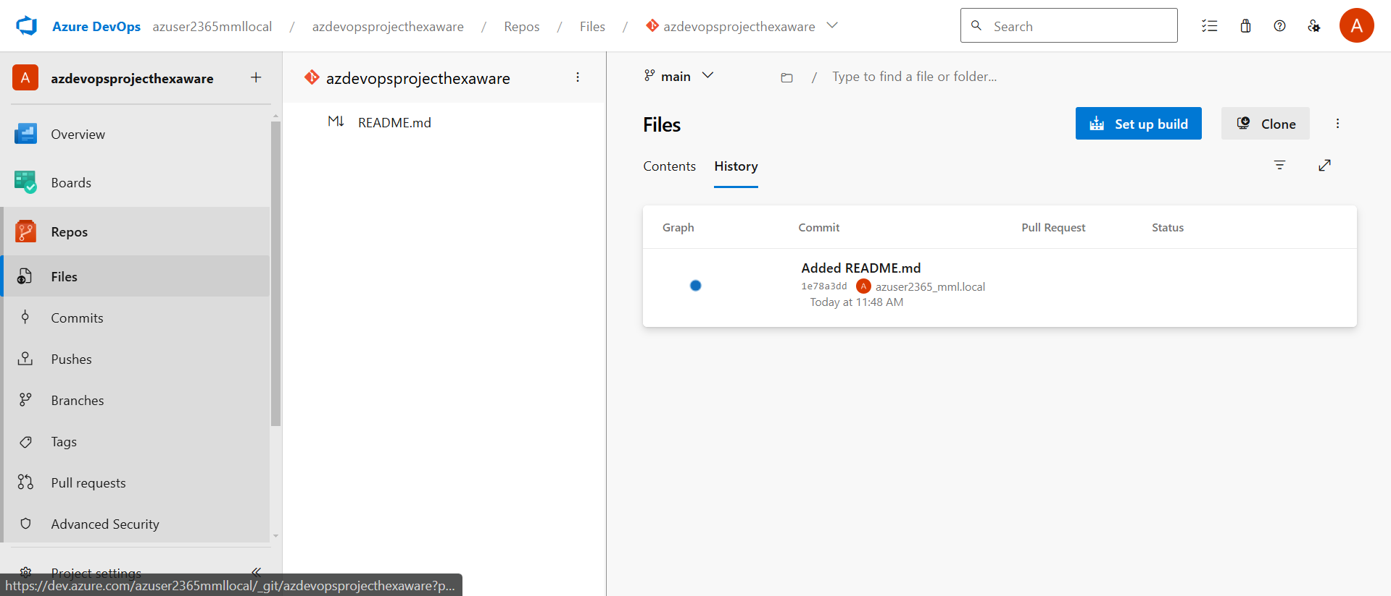

1. Linking Github to Azure Databricks:

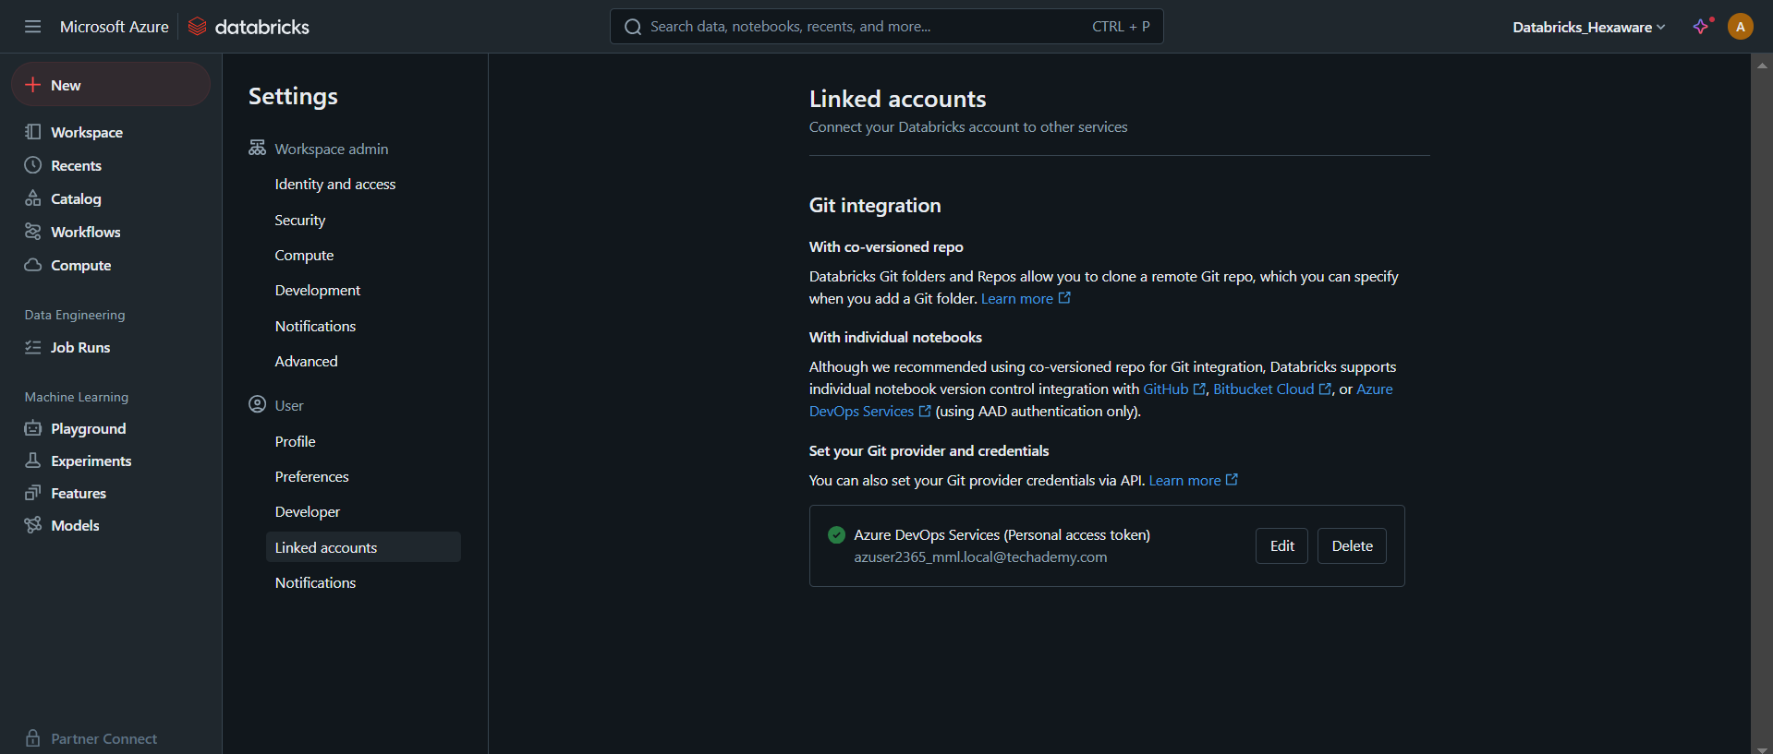

1. Setting up Azure Pipelines:

